### **Laboratory Tasks**

#### **Exercise 1: Exploring Android UI Architecture**

* **Step 1:** Create a new Activity named MainActivity.
* **Step 2:** Open activity_main.xml and switch to *Design View*.
* **Step 3:** Identify the Application Layer (your code), View System (widgets), and Window Manager interaction (preview/emulator).
* **Expected Output:** A simple interface containing a TextView displaying “Welcome to Android UI”.

OUTPUT:

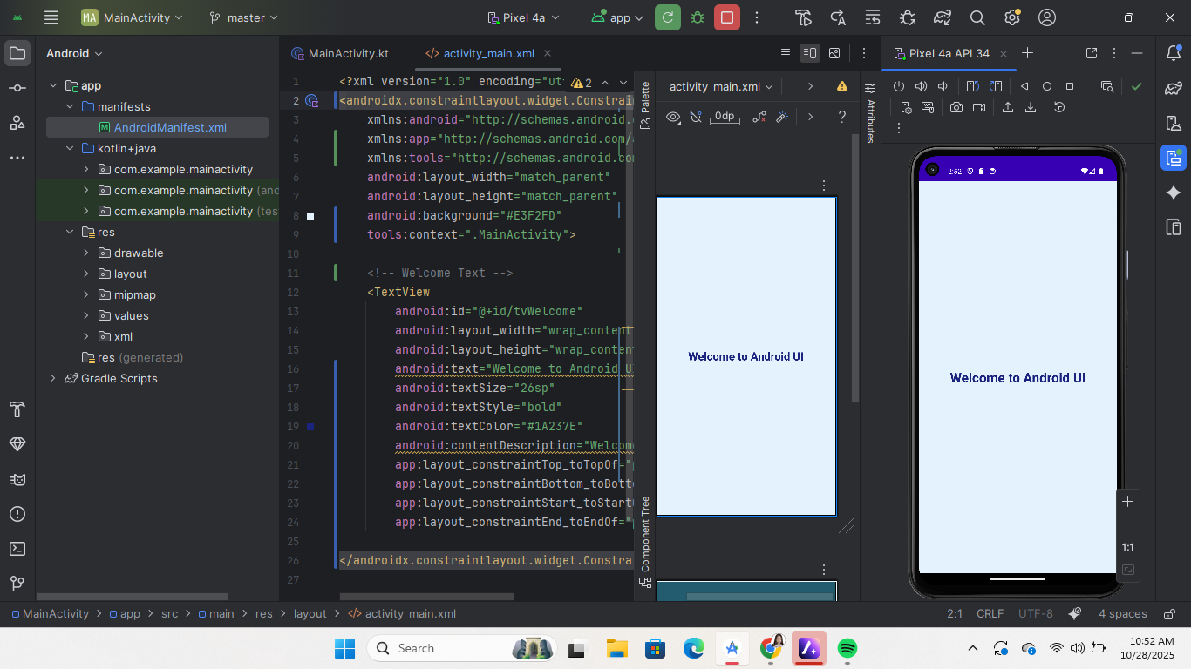

#### **Exercise 2: Designing Responsive Layouts**

* **Step 1:** Replace the default ConstraintLayout with a **ConstraintLayout** if not already used.
* **Step 2:** Add two TextView elements and one EditText.
* **Step 3:** Use dp units for padding, margin, and text size.
* **Step 4:** Preview the layout on two different screen sizes (e.g., Phone and Tablet).
* **Expected Output:** A UI that scales properly on different screens.

OUTPUT :

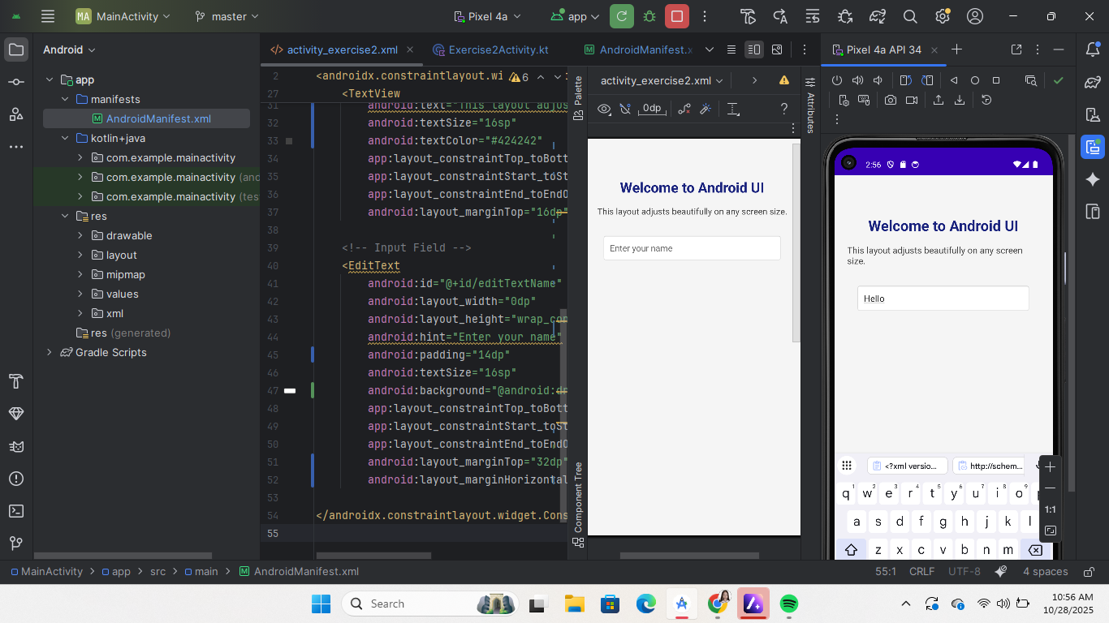

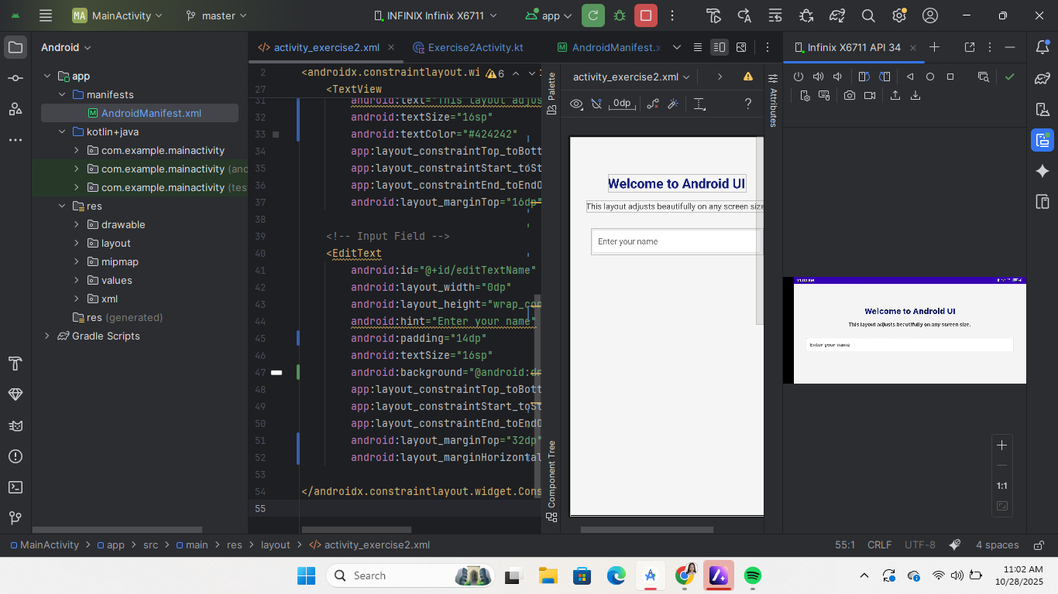

#### **Exercise 3: Implementing Text Controls**

* **Step 1:** Add a TextView for instructions.
* **Step 2:** Add an EditText for user input.
* **Step 3:** Add an AutoCompleteTextView with sample suggestions (e.g., list of countries).
* **Step 4:** Add a Spinner with 5 sample options.
* **Step 5:** Run the app and interact with text controls.
* **Expected Output:** User can input, see suggestions, and select from a dropdown.

OUTPUT

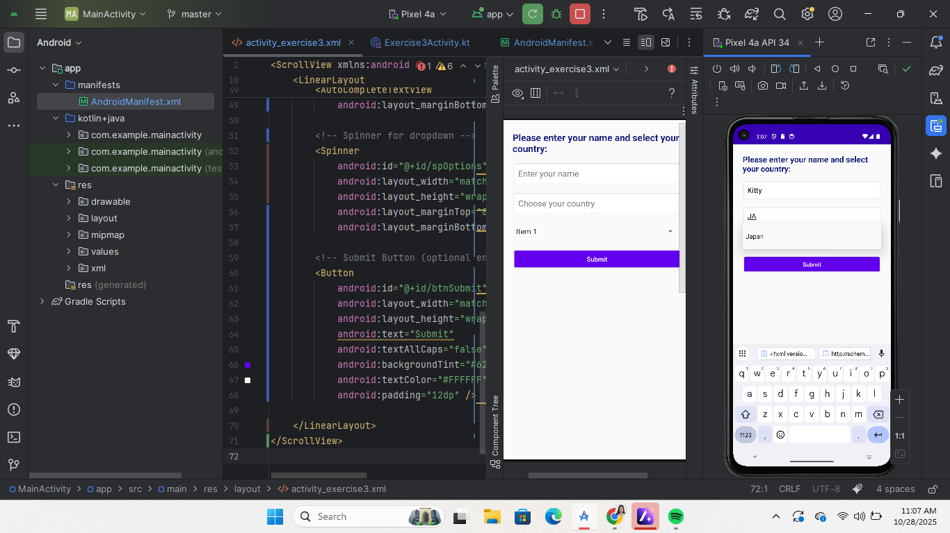

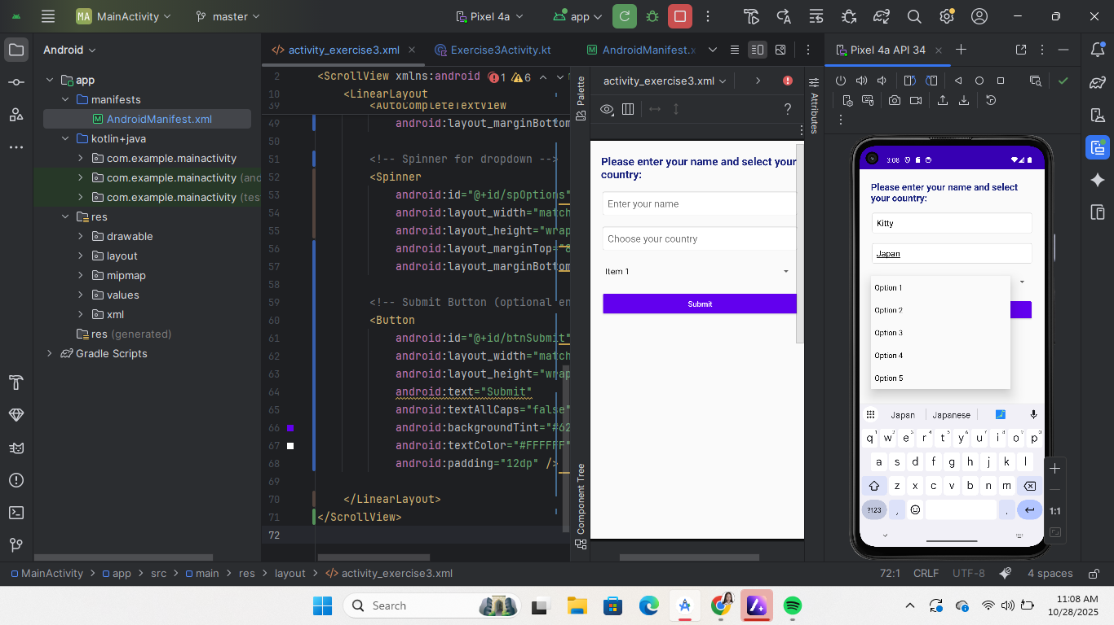

#### **Exercise 4: Working with Button Controls**

* **Step 1:** Add three buttons:  
  + Button — standard
  + ImageButton — with an image resource
  + ToggleButton — ON/OFF switch
* **Step 2:** Implement onClick event handlers in MainActivity.java or MainActivity.kt.
* **Step 3:** Add Toast messages to display button actions.
* **Expected Output:** Each button triggers a unique action when pressed.

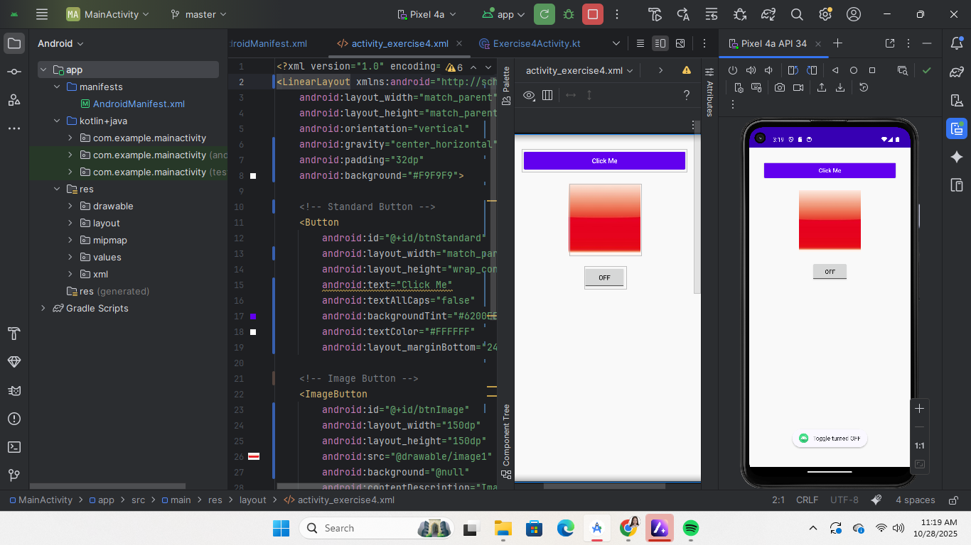

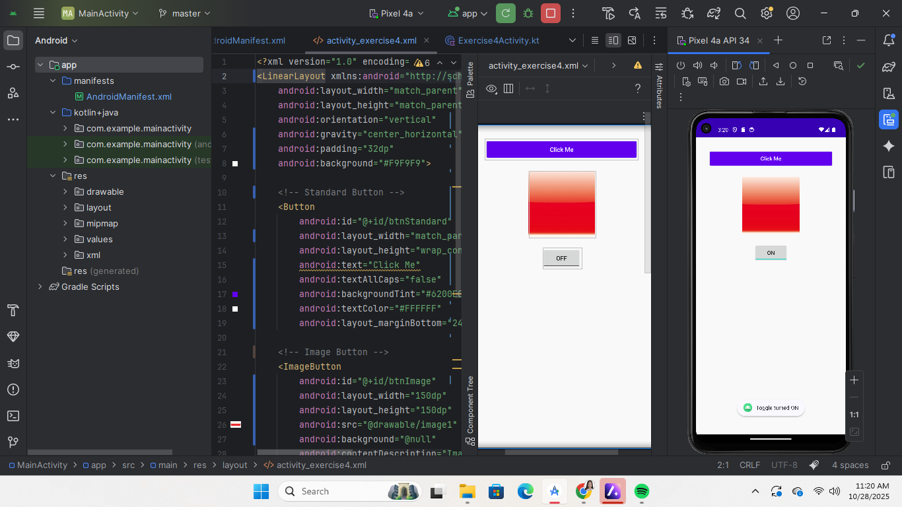

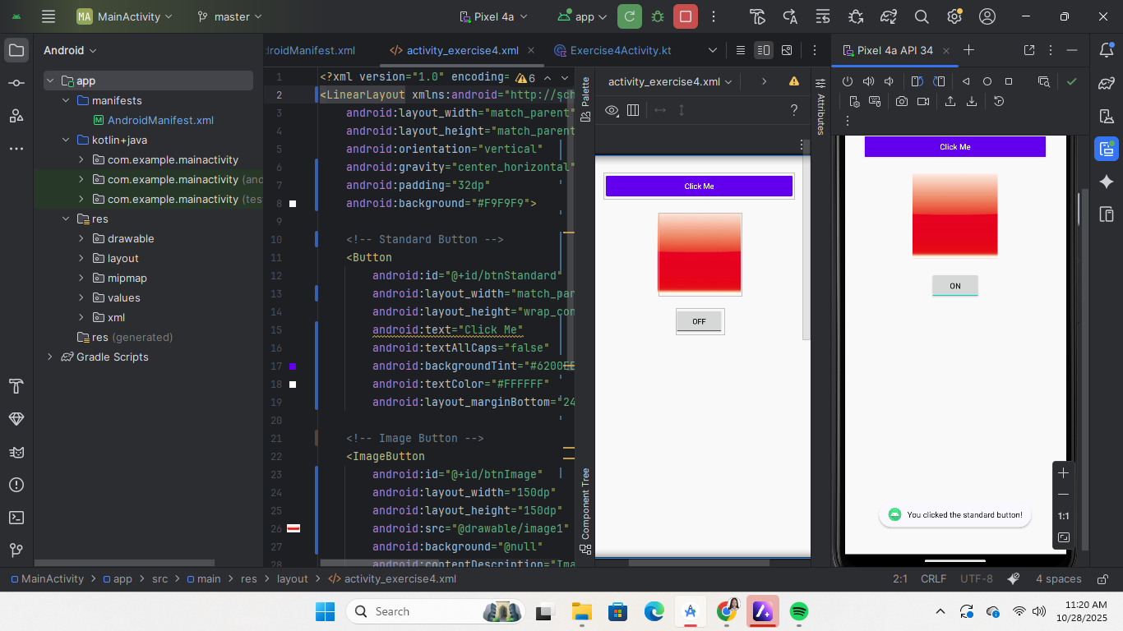

#### **Exercise 5: Using Image Controls**

* **Step 1:** Add an ImageView and set a drawable image.
* **Step 2:** Add an ImageSwitcher with two different images.
* **Step 3:** Add a button to switch between images dynamically.
* **Expected Output:** Users can toggle between images by pressing the button.

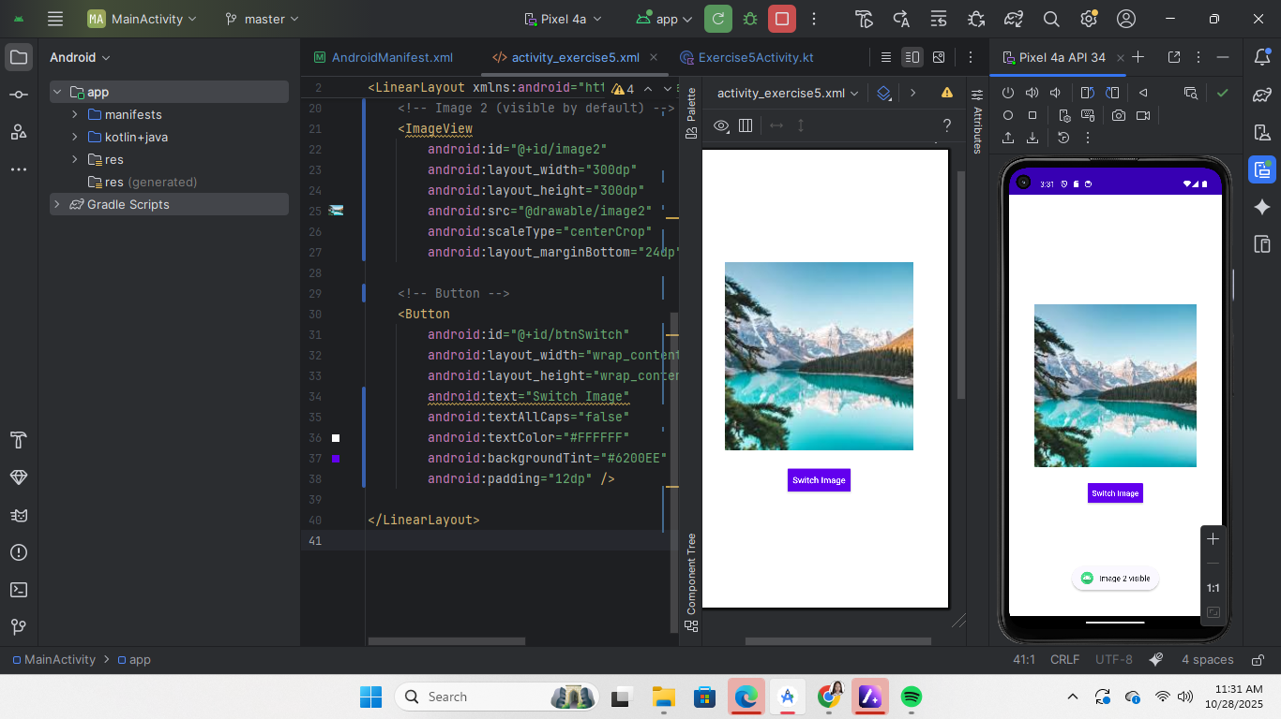

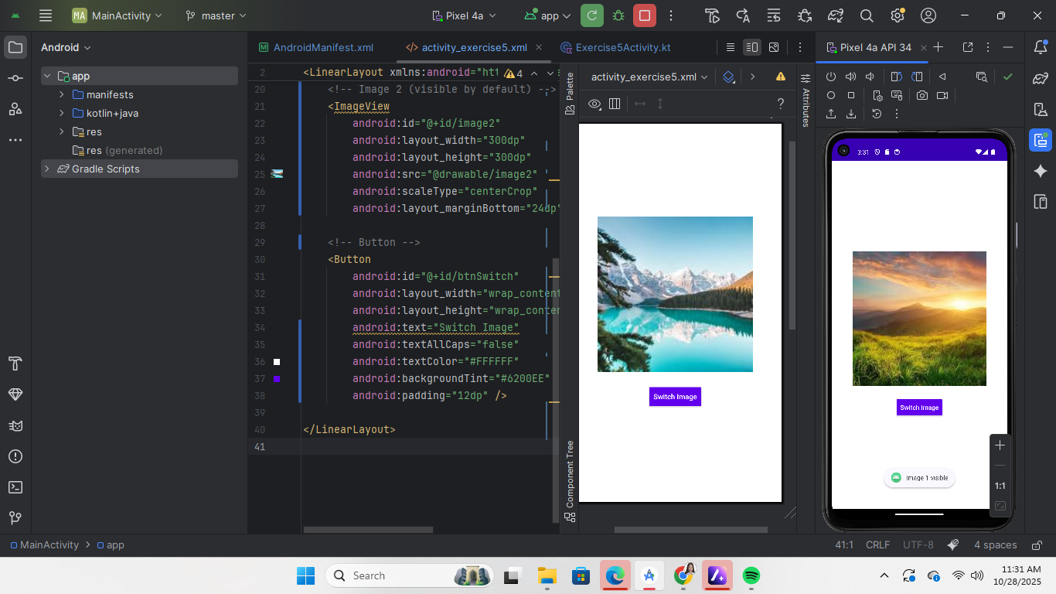

#### **Exercise 6: Applying UI Design Principles**

* **Step 1:** Adjust your layout to ensure **consistency** in color, font, and spacing.
* **Step 2:** Remove unnecessary elements for **simplicity**.
* **Step 3:** Enable contentDescription for images and labels for **accessibility**.
* **Step 4:** Ensure buttons and controls are easy to navigate for **usability**.
* **Expected Output:** A clean, accessible, and user-friendly interface.

